**TEAM Workshop – 21/02/2018**

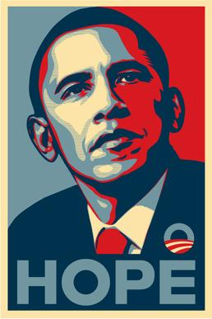**Read Colossians 1:3-8**

* When running for president in 2008, Barack Obama produced a simple poster which showed a stylised picture of his face, with the word ‘hope’ emblazoned below. What is it about hope that made this such a powerful image?
* In this passage, Paul talks a bit about hope.
  + What is the effect of the hope he talks about?
    - What is the relation between hope, and faith and love?
  + What does it mean for the hope to be ‘stored up in heaven’?
  + What’s different about this hope, and the hope people might put in a political leader?
* So why does Paul thank God for the people’s faith and love?
* How did the Colossians learn about this hope?
  + From the true message of the gospel (v5)
    - How does the gospel produce hope?
  + Which they heard from Epaphras (v7)
    - Where did Epaphras hear about the gospel?
* And beyond Colosse, what else is the gospel doing?
  + What does it mean for the gospel to be ‘bearing fruit and growing’?
* Bringing this together, what is the pattern we see for how the gospel spread and transformed people in the 1st century AD?
  + Revelation to Paul (and apostles) -> Passed on by Epaphras -> People Hear -> Learn of Hope -> Produces Faith and Love
* Today we can’t go and speak to Paul or have Epaphras pass on what he said. How do people continue to learn about the gospel?
* What does this passage tell us about the work of the gospel in our own lives?
* What does this passage tell us about our role in the continued work of the gospel?